ARABIC
For Class X (marks 75)

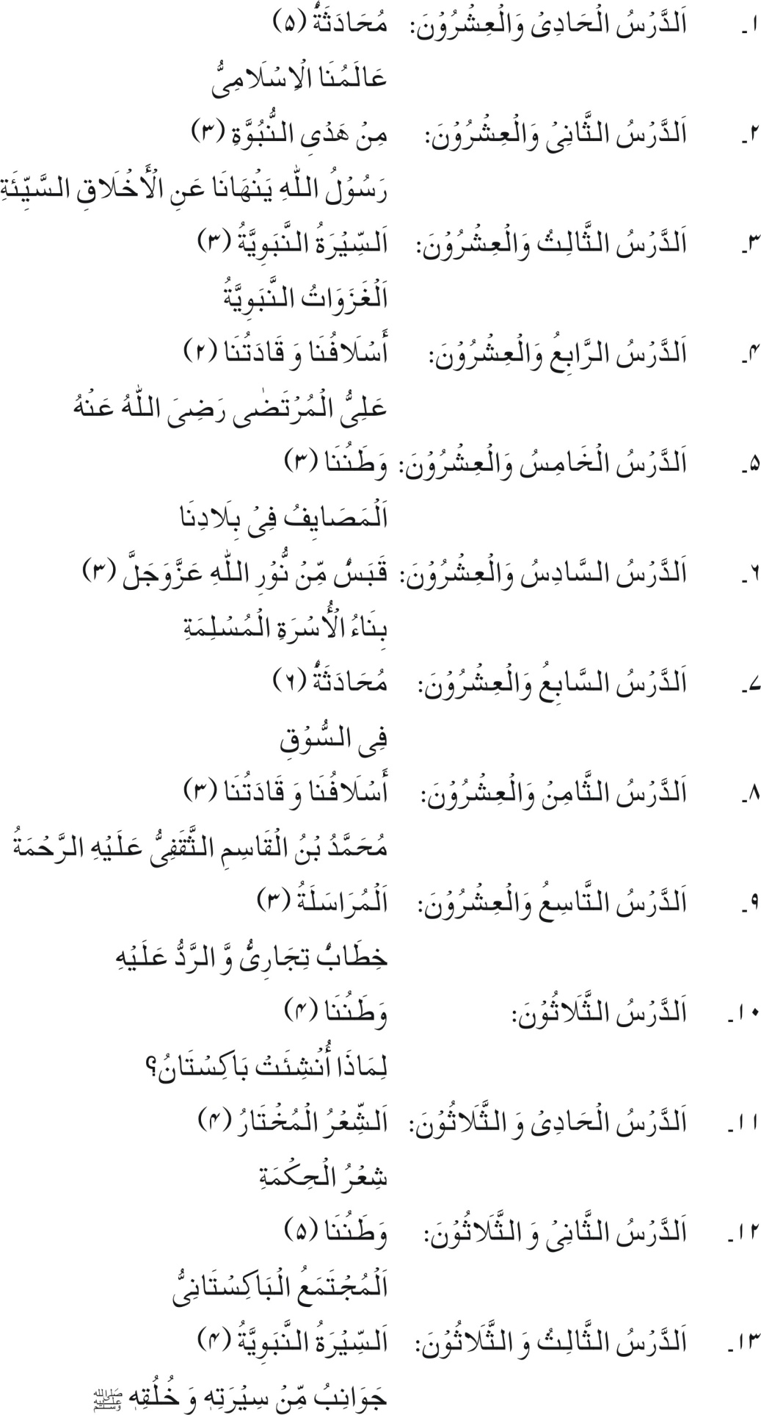
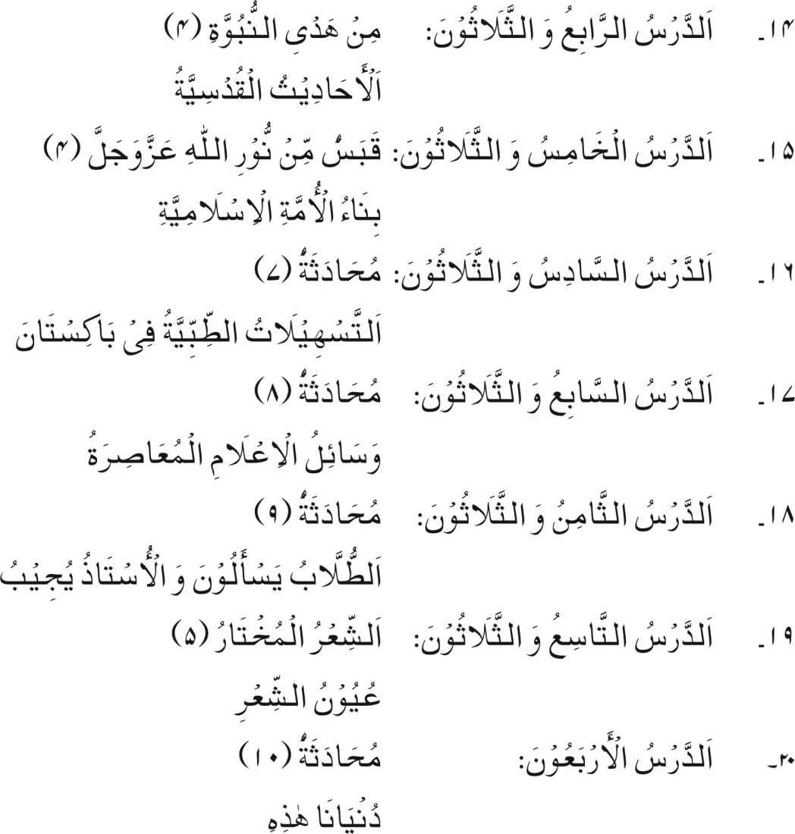

RECOMMENDED REFERENCE BOOKS FOR CLASS X

The question papers will be syllabus oriented. However, the following books are recommended for reference and supplementary reading:
